**Business Intelligence**

BIA-5401-0LA

Group Case Study 3

**Building a Customer Feedback Intelligence System using Web Scraping & Text Mining**

**Group:** 6

**Team Members:**

1. Alexandra Gladkova
2. Bishwajit Dutta
3. Christina Saju
4. Hao Lun Rong
5. Kushwanth Sai Kolli
6. Ladan Asempour

**Submitted to:** Professor Haytham Qushtom

**Submission Date**: 4/16/2025

* **Percentage of positive and negative reviews:**

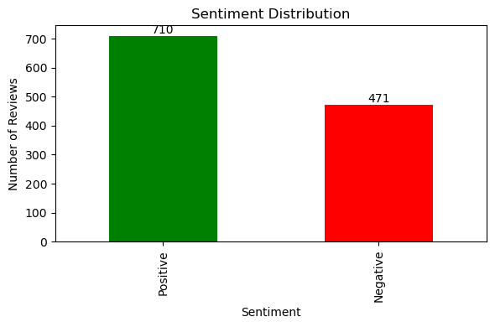

Based on the bar chart we can see that out of the 1181 reviews scrapped, 60.12% were positive while 39.88% were negative.

* **Most frequent words in positive and negative reviews:**

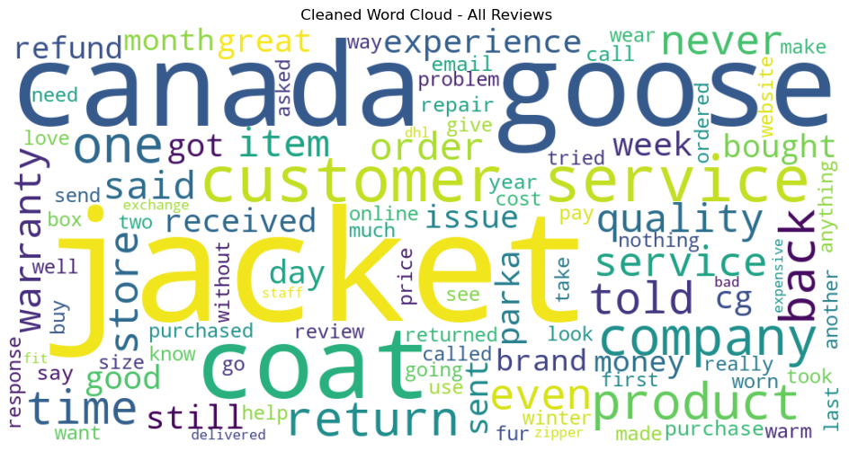

The figure above shows us the most frequent words used in reviews overall. However, if we compare positive v/s negative reviews, we see the following.

**The top 15 most frequent words appear in the reviews**:

|  |  |  |  |  |
| --- | --- | --- | --- | --- |
| **Rank** | **Word (Positive)** | **Frequency** | **Word (Negative)** | **Frequency** |
| **1** | jacket | 363 | canada | 475 |
| **2** | canada | 340 | goose | 473 |
| **3** | goose | 318 | jacket | 462 |
| **4** | service | 257 | customer | 376 |
| **5** | customer | 213 | service | 365 |
| **6** | coat | 186 | coat | 308 |
| **7** | great | 159 | back | 285 |
| **8** | quality | 155 | company | 250 |
| **9** | store | 136 | would | 223 |
| **10** | would | 134 | never | 186 |
| **11** | one | 128 | sent | 186 |
| **12** | back | 128 | warranty | 172 |
| **13** | warranty | 128 | return | 172 |
| **14** | product | 109 | one | 160 |
| **15** | time | 104 | told | 157 |

* **Key products with the most positive or negative feedback:**

Based on the visualization and the table above we can see that the one product with the greatest number of feedback is the Canada Goose Jacket/ Coat.

* **Business recommendations based on the analysis**

Based on what we found in the customer reviews, here are some business suggestions:

The “Canada Goose Jacket/Coat” receives the highest volume of reviews which make it a key product to monitor. The company should pay close attention to the sentiments expressed in both positive and negative feedback about this item.

With 60.12% of reviews being positive, many customers are clearly satisfied. Commonly used words like “great”, and “quality” highlight key strengths. These should be emphasized in marketing campaigns and messaging to reinforce the brand’s strong points.

Positive reviews often mention "jacket", "Canada", "Goose", "coat", "service", "customer", "great", and "quality". These associations reflect customer satisfaction and can be featured for marketing materials, customer testimonials, and product descriptions.

Words like "customer", "service", "back", "warranty", and "return" appear often in negative reviews. This may show customer frustration with service interactions, returns, or warranty claims. Improving these processes such as simplifying returns or providing clearer warranty information could reduce dissatisfaction.

The frequent use of the word "sent" in negative reviews points to possible issues with shipping, such as delays or incorrect orders. Reviewing and optimizing logistics and workflows can be helpful to ensure a smoother customer experience.

Some terms like "never" or "told" hint at communication problems or met expectations that they were not meet. A more in-depth review of these comments in the context could uncover specific recurring issues that worth addressing.

Some words like "service", "customer", and "back" appear in both positive and negative reviews. Understanding the context in which these words are used can reveal better insights. For example, customers may praise helpful service in one case but criticize slow response times in another.